Motor Fuel XML Redesign

Outstanding Questions for the Uniformity Team

Sept. 19, 2008

Team Members:

- Doreen Warren
- Larry Hanson
- Stan Whaley
- Cheryl Gilson

- And various Uniformity and TIGERS committee members.

Comment: The XML design team would like to stress that we are committed to creating the XML schemas that support the Uniformity EDI guidelines and Principles. (Uniformity EC committee confirmed that we should develop schemas that utilize this direction as closely as possible. Don’t include optional elements and/or structures unless explicitly stated, as a “standard”, within the existing EDI guide).

- Header/ Filer Type Issue (State License Number):

Which identifying information should be permitted at the Filer return/report level?

Option 1:
- Require at least 1, at most 2 of FEIN, SSN, CBN, State License Number

Option 2: Committee agreed with our recommendation (Filer level only include optional
SLN)
- Require 1 of FEIN, SSN, CBN
- State License Number optional

Recommendation: Option 2 as it most closely resembles the current EDI Implementation Guide.

Option #2

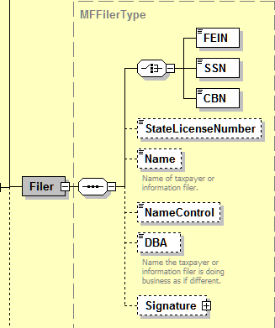

Basic XML

* Solid connecting line “_________“means the data is mandatory

* Dashed connecting line “------“means the data is optional

* Choice Gate means you can only select one data element per loop

* Plus sign in the box means there is one or more data elements. Click on box to expand.

  - Connect dots in the box means data must be in that order/sequence.

Option #1 - Rejected

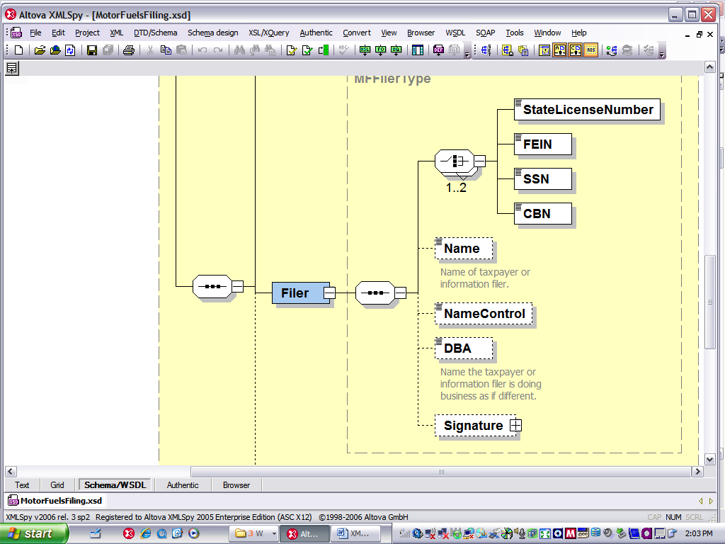

- General Schedules Issue

Which identifying information should be included in the schema at the schedule level for carriers, sellers, buyers, position holders and consignors? (Structure used all schedules and returns).

Option 1: Committee decided to not allow the State License Number.
This is consistent with the current Uniformity EDI standards and Business Rules.
- Include only FEIN, SSN or CBN

Option 2:
- Include FEIN, SSN, CBN, or State License Numbers

Option 3:
- Include FEIN, SSN, CBN, or State License Numbers in the schema; since the uniformity standard is to not require license numbers; any state that did would be deviating from uniformity, but this option would allow those states (and taxpayers that file in those states) to still take advantage of the uniform schema

Recommendation: Option 1 or 3
Option 1 most closely resembles the current EDI Implementation Guide.
Option 3 resembles actual practice from several states with optional SLN.

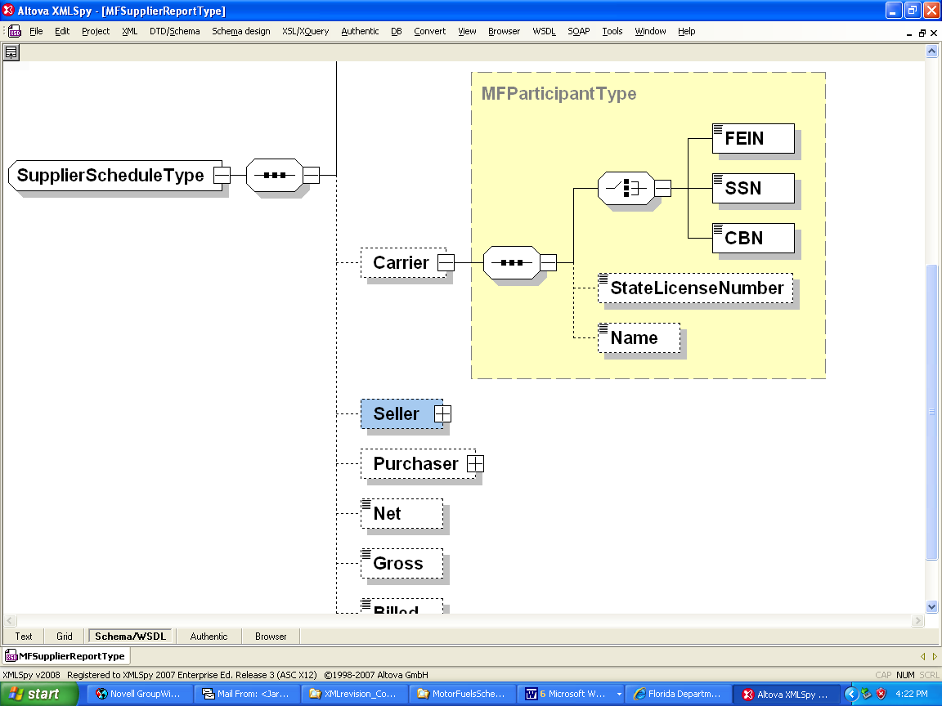

- Schema flexibility issue

How much flexibility should be built into the uniform XML Schema?

Examples:
On supplier schedules, should origin and destination always be required?
On terminal operator schedules, should carrier always be required? (Some jurisdictions don’t require all fields when industry re-brands fuel)

Option 1:
- Make schema firm – if state deviates from uniform schema, they are not uniform and will have to create their own schema

Option 2: Committee agreed with our recommendation. Stay with existing Business Model.
- Make schema flexible –Uniformity Committee would set standard rules or ‘best practices’ using schema structure; this option requires more responsibility on e-commerce to review xml implementation guides and from individual states to comply with uniformity guidelines

Recommendation: Option 2 – this most closely resembles current EDI implementation guide & uniformity practices

- Non-IRS Terminal Reporting

Will XML schema handle reporting for non-IRS (unapproved) terminals within the terminal report?

Option 1:
- Make terminal code optional

Option 2: Committee agreed with our recommendation. Also remove the TCN
pattern. This would allow states to use back end system to validate (could use Non-TCN number). These are currently Bio-Diesel producers, but could have additional IRS TCN types in future.

- Leave terminal code as required. Re-address this issue if a uniform method of reporting non-IRS terminals is added

Recommendation: Option 2

Question: Do we need to consider making the TCN longer than 9 characters?
Committee said we should remain nine alphanumeric.

- Terminal Report Details

Should calculated fields (total receipts, total available, total disbursements, quantity available) from the terminal operator form be included in the XML schema?

Option 1:
- Include these totals; they are on the form and should be allowed in the xml schema

Option 2: Committee agreed with our recommendation, but we need to verify
“exceptions” that should be included (in schemas). See Note:
- Do not include these totals; uniformity guidelines are not to require fields that can be calculated

Recommendation: Option 2

Exceptions: Summary (control figures) totals such as Total Net Reported or Total Net Transported. These allow states that aren’t at the rack to reconcile with schedules. Other states need to confirm taxpayer intent. We agree that totals that can be calculated from the schedule detail shouldn’t be included.

- Optional Product Type

Should we have the Product Type as an optional element at the current level? This means that all data below would be linked to the product type, if provided, but it could be sent without a product type (inventory without a product) as presently structured.

Option 1:
- Leave Optional Product type at its current level within schema. This would means all data below could be sent without a product.
Option 2:
- Make Product type mandatory at it current level within schema. This means that a product is required by schema, but would enforce all data is associated with the product (including Credit element)
Option 3: Committee agreed with our recommendation. Question concerning making
Product type mandatory within MFReportDetailType. It appears with need to
make it mandatory.
- Leave Optional Product type at its current level within schema, but also provide non-product specific elements at higher level of schema to allow for data (ex. Credit) that isn’t associated with a particular product type.

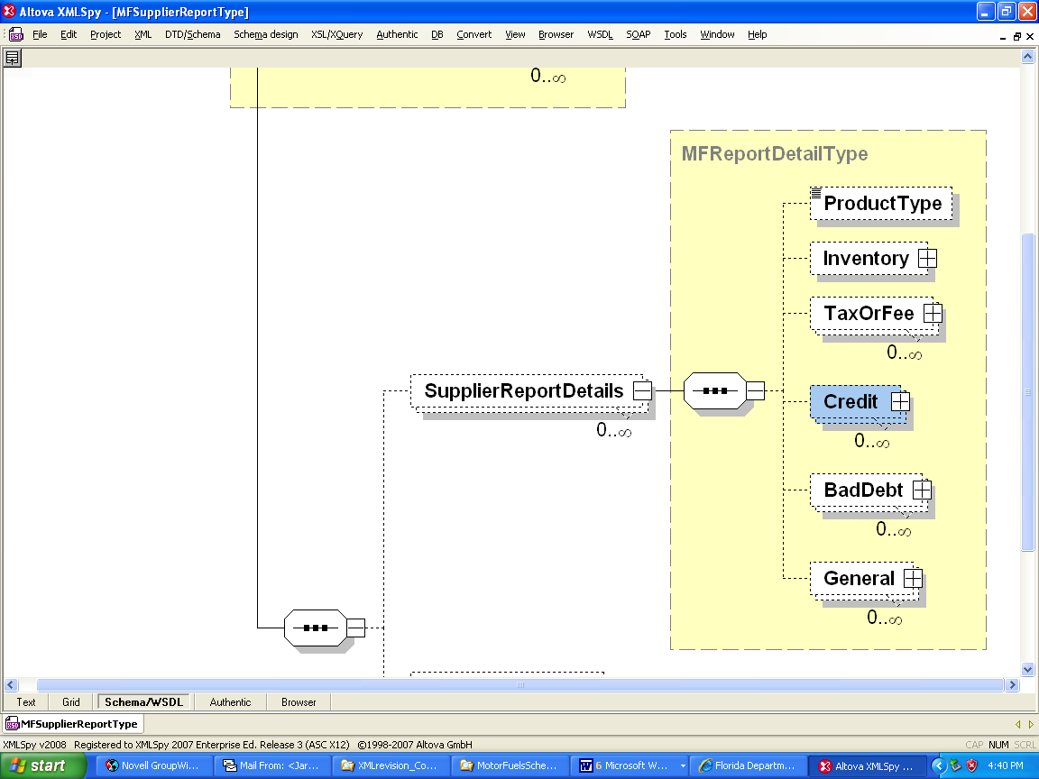

The next example allows for both Credits that are Product specific and the “summary” Credits that aren’t product specific.

* Product Type becomes mandatory in the following option.

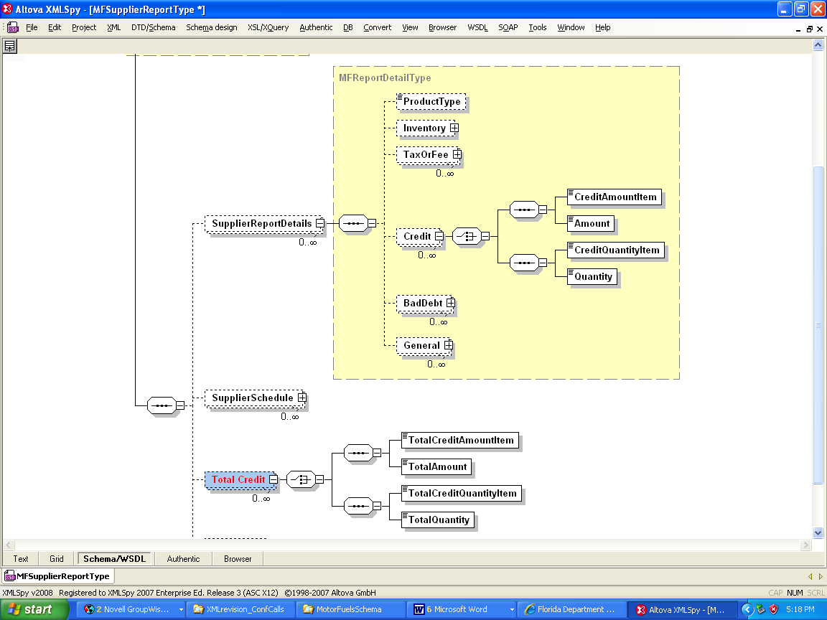

Follow up Meeting:

- We will hold a Conference Call and WebEx on either Oct. 7/8th to confirm the results from the Uniformity meeting. Doreen Warren and Larry Hanson weren’t able to attend this meeting.

- XML redesign team will make changes and produce a new draft before the Dec. TIGERS meeting.

- We will report back to the Uniformity Committee at their Jan. 9-10th. We should have the final draft ready for distribution.

- We still need to provide documentation about the XML schemas for the Uniformity EC Implementation Guide.

  - XML 101 (limited XML expertise in the Uniformity EC Committee)
  - High Level explanation of how the XML differs from traditional X12 EDI.
  - Explanation of specific structures within Schemas such as Enumerated List Type.
  - All will need to be ready by the May 2009 Uniformity Meeting for inclusion in the 2009 Guide.

